YOSYS

$ sudo apt-get update

$ git clone <https://github.com/YosysHQ/yosys.git>

$ cd yosys

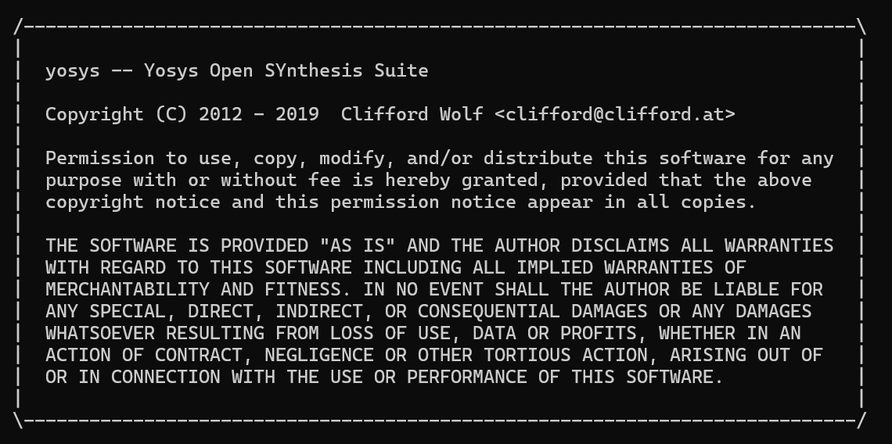

IVerilog

$ sudo apt-get update

$ sudo apt-get install iverilog

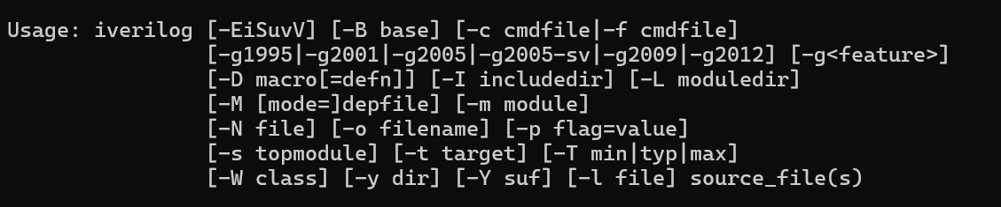

Gtkwave

$ sudo apt update

$ sudo apt install gtkwave

